**Final Design: (Aryaman)**

In the culmination of our design proposal for the rescue robot tasked with retrieving a tennis ball in a complex maze consisting of rough terrains, we present a final design that leverages a lifting mechanism, multiple sensors, as well as sufficient manoeuvrability. The design concept has evolved through rigorous brainstorming, concept generation techniques such as mind mapping and morph chart matrix, and the input from team members as well as educators and mentors.

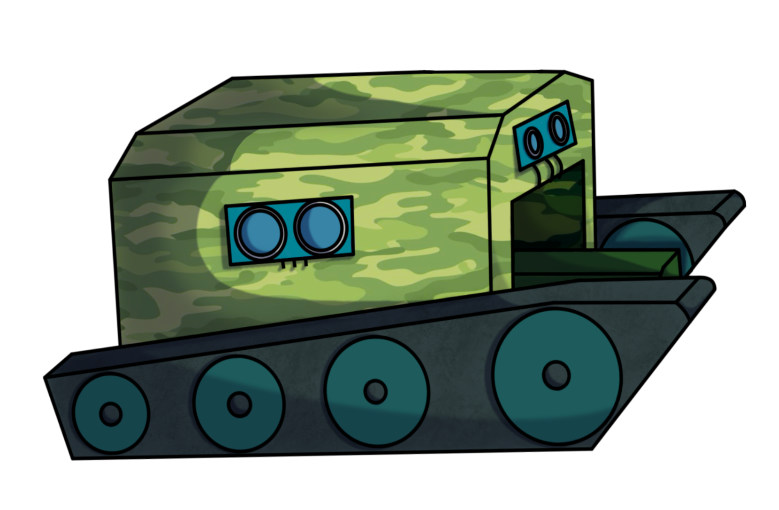The following section provides an in-depth discussion of the final design, accompanied by detailed sketches, diagrams, and cost considerations.

**Figure 1: Rescue Robot Design (Coloured) – Designed and Sketched on Procreate by Aryaman Sakthivel**

**Design Concepts:**

The design concept for the rescue robot revolves around the efficient retrieval of the tennis ball within a maze whilst avoiding collisions. The critical feature in our approach involves a lifting mechanism which is used to pick up and store the tennis ball to safely transport it back to the starting point. Our design also features several proximity sensors used to ensure the rescue robot does not collide with the maze walls.

**Lift Mechanism:**

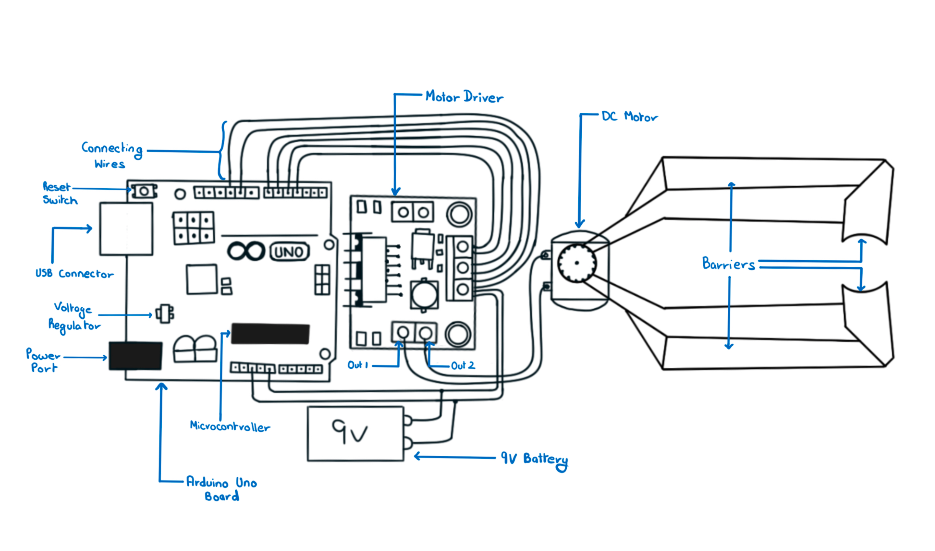Our chosen lift mechanism consists of two movable platforms with barriers in the front and on the outer side to prevent the ball from falling off while collecting as well as transporting. The apparatus will be controlled via a motor connected to the Arduino microcontroller, enabling precise retrieval with gentle ball handling. This mechanism will be integrated on to the robot’s chassis.

**Figure 2: Lift Mechanism Diagram designed and sketched by Aryaman Sakthivel**

**Mobility and Navigation:**

The robot’s mobility and navigation are essential considerations. In order to traverse the rough terrains and execute sharp turns within limited distances, we have opted for a “dual drive” system. We drew inspiration from the Tank steering system and opted to incorporate the 'continuous track' vehicle structure into our rescue robot.

**Dual Drive:** The dual drive system maintains power to both tracks during steering and can be used to change the speed of each track individually, thereby producing a wide range of turning circles. It even allows one track to move in reverse while the other moves forward, enabling the rescue robot to turn in place.

(Information cited from: The Evolution of a Tank Transmission by H.E. Merritt, M.B.E., D.Sc. (Eng.), M.I.Mech.E)

**Continuous Track:** The rescue robot runs on a continuous band of treads or track plates driven by two or more wheels. The principal design advantage of tracked vehicles is that they exert a much lower force per unit of area on the ground which makes them suitable for use on soft, low friction and uneven ground. Combined with wedged shaped wheels, the robot will be able to traverse up and down the stairs with ease.

(Information cited from: <https://www.robotpark.com/academy/all-types-of-robots/wheeled-robots/tracked-robots/>)

**Image 1: Robot Types – Wheeled Robots – Tracked Robots (Robopark.com)**

**Power Source:**

To power the robot’s various components, including the lift mechanism, multiple sensors, and motors, we have selected a 9V battery. This power source offers a balance between the energy capacity and weight, allowing for extended operation within the maze. The Arduino uno microprocessor can operate satisfactorily on power that is available from the USB port. It provides 5V DC voltage and can be sourced from the port from a laptop.

(Information cited from: <https://support.arduino.cc/hc/en-us/articles/360018922259-What-power-supply-can-I-use-with-my-Arduino-board-> )

**Sensing and Control:**

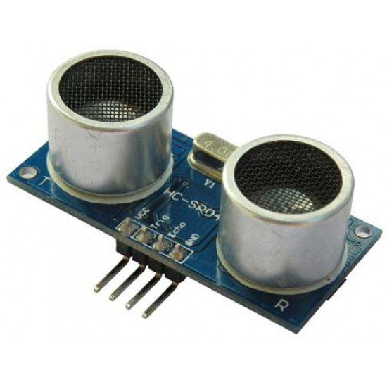To enhance the robot's functionality, we have integrated a combination of three ultrasonic sensors (one on each side of the robot and one in the front). These sensors provide real-time data to the robot’s control system, enabling it to navigate the maze and avoid obstacles effectively. The control system is based on an Arduino Uno microcontroller, which offers the required processing power and adaptability for the project.

We have decided to opt for the Ultrasonic Range Finder for our rescue robot project. This sensor detects the distance of the closest object in front of it (from 3 cm up to 400cm). It works by sending out a burst of ultrasound and listening for the echo when it bounces off an object. It pings the obstacles with ultrasound. The Arduino board sends a short pulse to trigger the detection, then listens for a pulse on the same pin using the pulseIn() function. The duration of this second pulse is equal to the time taken by the ultrasound to travel to the object and back to the sensor. Using the speed of sound, this time can be converted to distance.

**Image 2: Ultrasonic Sensor (from CREATE NSW Inc.)**

(Information cited from: <https://docs.arduino.cc/built-in-examples/sensors/Ping> )

**Design Innovation:**

Our rescue robot project embraces a design innovation that elevates the capabilities and applications of rescue robotics. The core design concept revolves around the efficient retrieval of tennis balls within a maze, but our approach goes beyond this primary objective, introducing groundbreaking innovations:

**Lifting Mechanism Advancement:** The decision to integrate a lifting arm mechanism, providing adaptability and precision, represents a significant innovation. This mechanism ensures reliable and secure tennis ball retrieval while accommodating variations in ball (victim) size and weight. It also provides safe transportation of the ball back to the starting area.

**Tank Steering Inspiration:** The tank steering (dual drive) system as well as the ‘continuous track’ structure offers exceptional mobility and terrain adaptability. This innovation enhances the stability, manoeuvrability, and load-bearing capacity, al while minimizing environmental impact and maintenance requirements.

**Multi-Purpose Adaptability:** While our primary task is tennis ball retrieval, the design innovations we've introduced make our rescue robot adaptable to a wide range of applications. Its lifting mechanism, mobility, and sensor integration (on a larger scale) can find utility in diverse scenarios, from search and rescue operations to environmental monitoring.

**Camera System Removal:** Extensive analysis revealed that the camera system, while valuable in certain applications, is not a necessary feature for the core task of retrieving tennis balls within the maze. This is primarily because the operator will have constant visibility of both the maze and the rescue robot throughout the extraction process.

By removing this component, we effectively streamline the robot’s design and can focus on strengthening its other aspects. This decision ensures that resources are allocated efficiently and contributes to cost reduction without compromising the primary function of the rescue robot.

**Technology Integration:** The use of an Arduino Uno microcontroller enhances control and adaptability. It allows for seamless integration with sensors as well as precise control over the motors which are responsible for the lifting mechanism and the mobility, exemplifying our commitment to innovation technology integration.

**Resource Efficiency and Cost-Effectiveness:** The integration of these innovations aligns with our project’s goals. By optimizing our design and maximizing efficiency, we ensure that the robot excels in its primary mission while remaining cost effective. Although these innovations are individually significant, collectively they contribute to a well-balanced and innovative rescue robot.

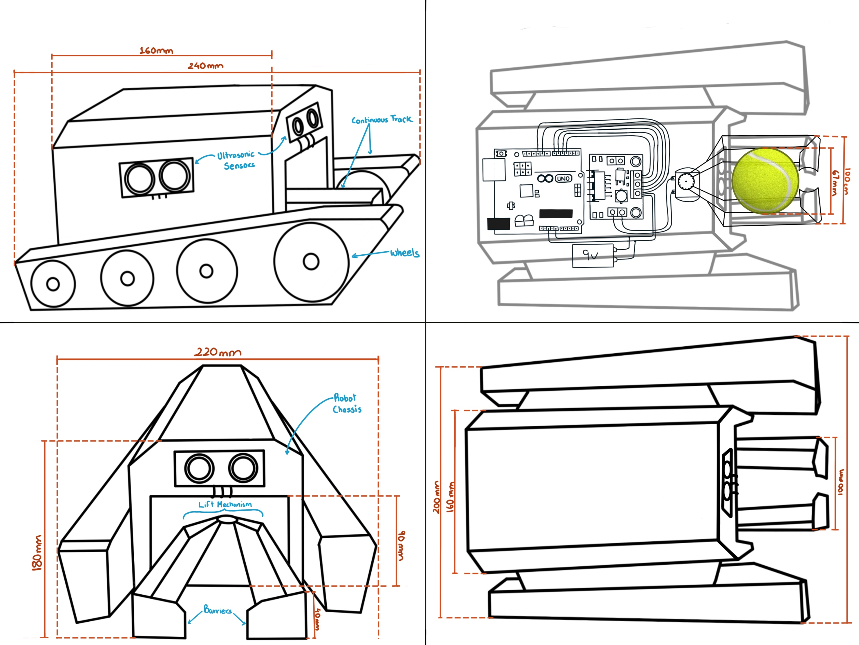**Final Design Sketch:**

**Top View**

**Front View**

**X-Ray View**

**Side View**

**Figure 3: Final Design – by Aryaman Sakthivel**

**Budget:**

The project budget has been meticulously considered to ensure that financial resources are allocated efficiently. The detailed budget overview in Table 1 outlines the estimated costs, allowing for effective resource planning.

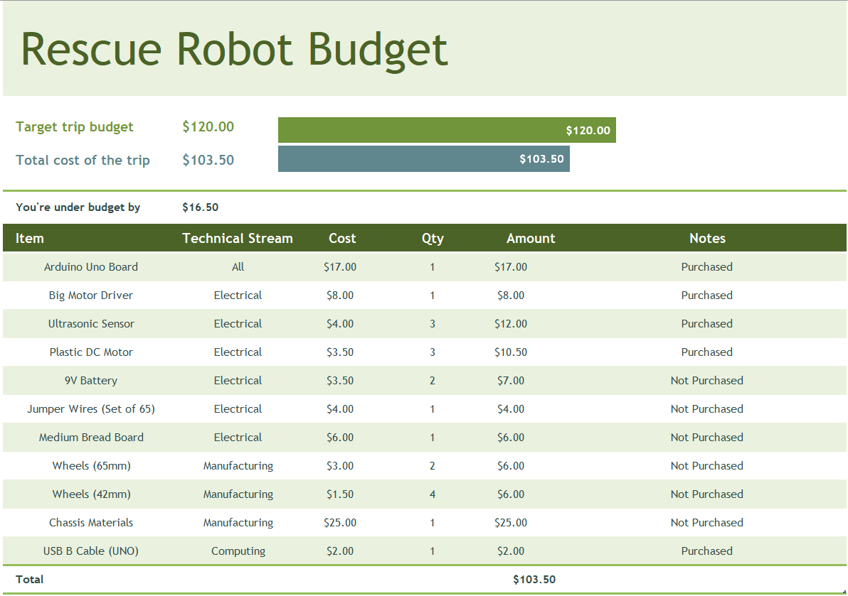**Table 1: Rescue Robot Budget Table – Team 6**

Effective budget management is a crucial component of our rescue robot project, especially with a limited budget $120 for the entire project it is necessary that the project remains financially viable. Here, we delve deeper into the key aspects of our budget management strategy:

**Cost Estimation:** The budget process begins with a comprehensive cost estimation, which considers all expenses associated with the project. This includes the procurement of materials, components, sensors, the Arduino microcontroller, power source, and the manufacturing process. Detailed cost estimates for each component are developed to create a comprehensive overview of project expenses.

**Resource Allocation:** We carefully allocate resources based on the project's requirements. Resources are allocated according to the importance of each component in achieving the project's objectives. This ensures that critical components receive the necessary funding to ensure optimal performance. The Pie chart 1 shows the allocation for each of the technical streams.

**Pie Chart 1: Budget Allocation for Technical Streams**

**Contingency Planning:** Our budget strategy includes provisions for unforeseen expenses. A contingency fund is established to address unexpected challenges or component failures. This ensures that the project remains on schedule and on budget, even in the face of unexpected issues.

**Prioritization of Key Components:** Within our budget strategy, we prioritize the allocation of the budget to the core components that directly impact the rescue robot’s primary function. This includes the motor driver, the ultrasonic sensors and the Arduino microcontroller.

**Streamlining Resources**: While prioritizing essential components, we also aim to minimize resource allocation to non-essential elements. The removal of the camera system, for instance, represents a conscious choice to optimize budget allocation. This strategic decision contributes to cost reduction while maintaining the project's core functionality.

In summary, our budget management approach is a critical aspect of our project, providing financial oversight, resource allocation, and cost-efficiency. Through prudent planning and continuous monitoring, we ensure that the rescue robot project remains on target, within budget, and capable of delivering an effective and cost-effective solution for retrieving a tennis ball within a maze.

**Conclusion:**

This design proposal encompasses the culmination of our efforts, resulting in a final design that addresses the project's goals and requirements. The lift mechanism, mobility system, power source, sensors, and control components have been carefully chosen to ensure the rescue robot's success. This design proposal will serve as a blueprint for the robot's construction and subsequent testing phases.